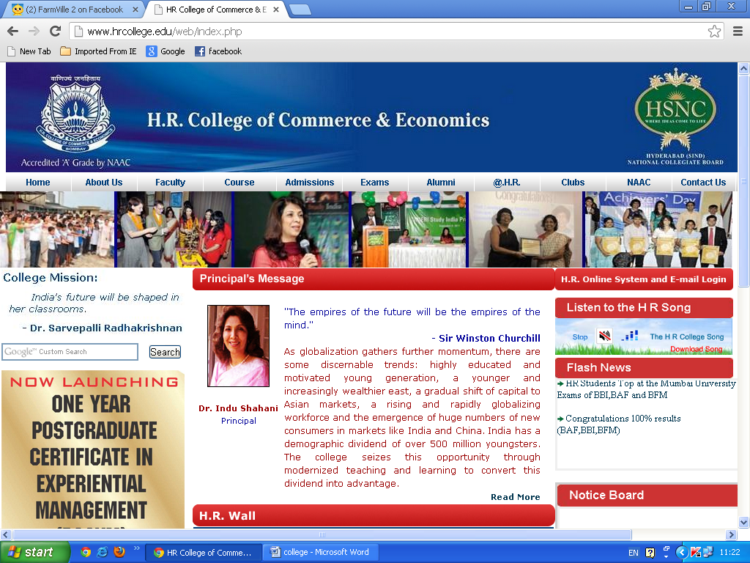

Home

|  |  |  |
| --- | --- | --- |
| http://www.hrcollege.edu/web/images/indu_shahani.jpg | http://www.hrcollege.edu/web/images/trans.gif **“The empires of the future will be the empires of the mind.” - Sir Winston Churchill** |  |
|  | |  | | --- | | As globalization gathers further momentum, there are some discernable trends: highly educated and motivated young generation, a younger and increasingly wealthier east, a gradual shift of capital to Asian markets, a rising and rapidly globalizing workforce and the emergence of huge numbers of new consumers in markets like India and China. India has a demographic dividend of over 500 million youngsters. The college seizes this opportunity through modernized teaching and learning to convert this dividend into advantage.  Professionalization of higher education is a daily practice at H R College and it has been our constant endeavour to prepare future managers for global challenges. We continue to forge even stronger relationships of trust with the Mumbai corporate cosmos. In our professional courses, the budding managers have ample opportunity to interact and be trained by corporate gurus. Numerous knowledge-enhancement programs in the summer have been initiated in academic and non-academic areas.  Eminent corporates such as Infosys, Ernst & Young, ICICI Prudential, JP Morgan Chase, KPMG, Axis, Edelwiess, Franklin Templeton Investments, Tata Sons and ICICI Bank, BASF, among many others, visit our college for guest lectures, final placements and conduct of programs. Collaborations with universities all over the world have given students and staff of our college the opportunity to obtain international experience through exchange programs and international internships.  The academic results are always outstanding and the college perennially excels in intercollegiate festivals, sports and social service.  In this knowledge millennium we develop critical skills in our students combined with ethics. The support systems used for achieving our objectives include a well-equipped, air-conditioned library, techno-savvy classrooms, state-of-theart computer laboratories and activity centres for students. The heart of the college, however, remains the quality of its teaching and the excellence of its faculty.  We look forward to making a meaningful difference in the field of higher education and in nurturing the leaders of tomorrow. | | |

About:

College Profile

H.R. College of Commerce & Economics is one of the leading commerce and management colleges, affiliated to the prestigious University of Mumbai (Bombay). Today, there are over 6000 students and each year the institution grows from strength to strength.

The College has achieved excellent academic standards, while simultaneously creating opportunities for the all round development of students through sports and cultural activities by transferring the responsibility of the learning to the learner. The College empowers students and fosters young leaders.

H.R. College was the first college in Maharashtra to be accredited 'A' grade with a score of 87.95% by the NAAC (National Assessment & Accreditation Council) in 2002. In 2008, HR College was awarded an 'A' Grade by NAAC once again; with a CGPA of 3.46, which we proudly proclaim to be the highest in Maharashtra.

H.R. College also has the unique distinction of having received autonomy in 2007 from the University Grants Commission (UGC), making it the first college in the 150-year history of the University of Mumbai to have achieved this feat. The College will implement autonomy in due course.

The college strives for excellence in teaching and learning at undergraduate / postgraduate levels. In 1994, the college introduced the UGC's Scheme of Vocationalisation with Advertising, Sales Promotion & Sales Management, Tourism & Travel Management, Tax Procedure & Practice and Principles & Practices of Insurance.

The college was first to introduce an Honours' Programme whereby alongwith the undergraduate program a student can earn honours credits as well. The conventional Bachelor of Commerce continues to be the core of HR College’s educational framework but the College has subsequently expanded to introduce other specialised courses in B.Com. The following degrees are offered by the college:

* **Bachelor of Commerce (B.Com.)**
* **Bachelor of Management Studies (BMS)**
* **Bachelor of Commerce – Accounting and Finance (BAF)**
* **Bachelor of Commerce – Banking and Insurance (BBI)**
* **Bachelor of Commerce – Financial Markets (BFM)**
* **Bachelor in Mass Media (BMM)**
* **Masters of Commerce in Business Management**
* **Masters of Commerce in Accountancy**
* **PhD Program**

Being at the hub of the business district, H.R. was the first college in Mumbai to initiate strong industry-academia relations. Industry experts are regularly invited to come and share their business strategies and experiences. This interaction helps the students to keep abreast with the latest developments in the business sector which in turn equips them for their professional lives. Each year the best names in the corporate sector offer H.R. students internships and placements.

Internationalisation has become the focal point of the teaching learning process at H.R. The college leads the way in student and faculty exchange programs. This exposure helps the faculty to understand the best practices of leading institutions and incorporate them in their teaching methods. The students are offered scholarships and exchange programs from institutions like NYU Stern , USA and King’s College, UK, which helps them gain a global perspective.

The institution has a very active alumni association. Some of our illustrious alumni who have excelled in all walks of life are: Kumar Mangalam Birla, Prashant and Anshuman Ruia, Gautam Singhania, Karan Johar, Anil Kamath, Luis Miranda, Neil Nitin Mukesh, Sunil Shetty, Aftaab Shivdasani, and Raj Mirchandani. Dr. Indu Shahani is also a proud alumnus of H.R. College.

We look forward to H.R. becoming synonymous with 'High Rankers' and its students with 'Higher Responsibility'. H.R.'s motto is 'Prosperity through Commerce' and the institution will continue to produce young leaders of high integrity, in the process fostering truly global citizens.

With Dr. Indu Shahani as Principal and a dedicated faculty, the college looks forward to the growth of all its courses old and new.

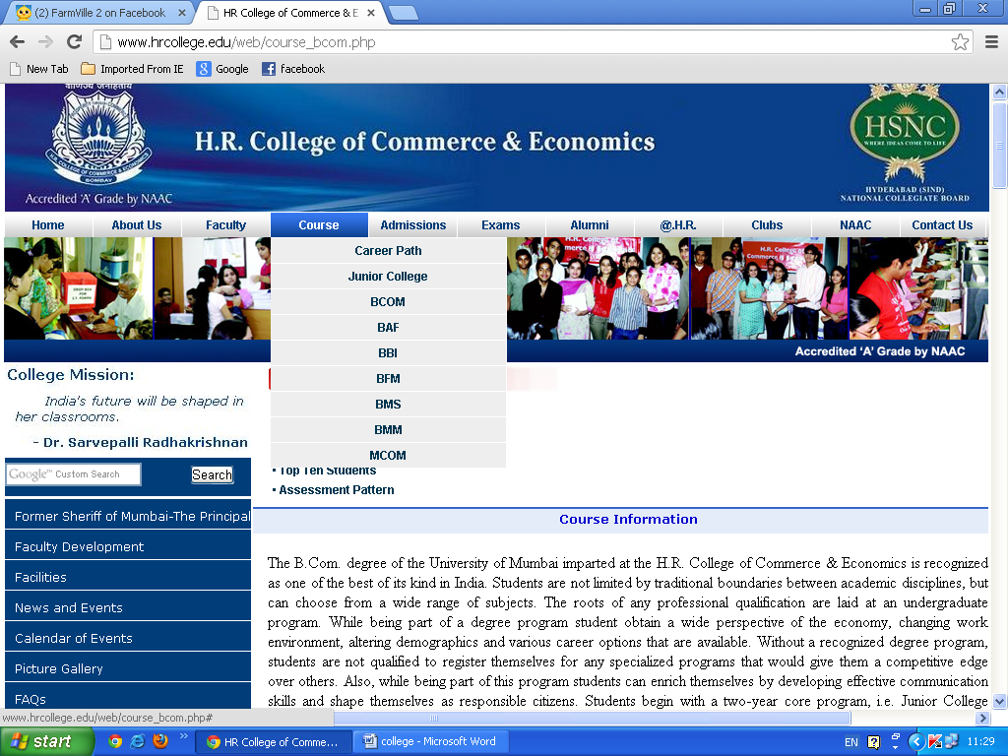

|  |  |  |  |  |
| --- | --- | --- | --- | --- |
| |  | | --- | |  |  |  | | --- | | [**• Syllabus**](http://www.hrcollege.edu/web/course_fyjc.php#syllabus) | | [**• Top Ten Students**](http://www.hrcollege.edu/web/course_fyjc.php#top) | | [**• Assessment Pattern**](http://www.hrcollege.edu/web/course_fyjc.php#assessment) | |
| **Syllabus**  Students in the First Year and Second Year Junior College will have to offer following subjects :  1. English 2. Environment Education 3. Economics 4. Organisation of Commerce 5. Book-keeping and Accountancy  They will have an option of selecting one Subject from each of the group mentioned below : Group I : Mathematics or Secretarial Practice Group II : Modern Indian Language (Hindi or Marathi) or Modern Foreign Language (French) or Information Technology  N.B.: A subject which is offered by less than 20 students will not be introduced in the College.    **Top Ten Students**  **F.Y.J.C. Toppers**   |  |  |  | | --- | --- | --- | | RANK | NAME OF THE STUDENT | PER% | | 1 | BAXI SOHAM SAMIR SUJAL | 91.29% | | 2 | Ms. JAIN JINI KIRAN NEETA | 88.86% | | 3 | Ms. TAPARIA ANJALI SANJEEV A. | 88.86% | | 3 | Ms. MEHTA DISHA JASWANT M. | 91.42% | | 4 | Ms. DHAWAN RAVEENA MUNISH G. | 88.71% | | 5 | Ms. PAREKH KHUSHBU BHARAT | 87.71% | | 6 | Ms. BANDHAMUTHA SNEHA RAMESH | 87.29% | | 7 | Ms. SETH TANVI NITIN ANU | 87.14% | | 8 | Ms. VASI ZAHRA ZULFIKAR RASHIDA | 86.29% | | 8 | JARIWALA PARTH AMITKUMAR H | 86.29% | | 8 | Ms. DUGAR MOHNISHA ARUN S. | 86.29% | | 9 | Ms. AGARWAL SANSKRITI ADITYA G. | 86.14% | | 10 | BANDYOPADHYAY ARKADEEP SUDIP | 86.00% |   **S.Y.J.C. Toppers**   |  |  |  | | --- | --- | --- | | RANK | NAME OF THE STUDENT | PER% | | 1 | JAIN JANAM ARVIND ANITA | 94.00% | | 2 | MEHTA KAUSHAL ASHISH PRITI | 92.50% | | 3 | JAIN MANSI KISHOR KALPANA | 92.33% | | 4 | JAIN DIVYA SUNIL ANJU | 92.00% | | 4 | SHAH AANGI BHAVIK TEJAL | 92.00% | | 5 | AGARWAL MEHAK SANJAY NEELU | 91.83% | | 6 | DHOLAKIA NIYATI MAHENDRA T. | 91.67% | | 6 | SHAH POOJA DINESH MANJU | 91.67% | | 6 | SANGHVI DIVYA RAJENDRA C. | 91.67% |     **Assessment Pattern**  The Higher Secondary Certificate shall be awarded in four grades as shown below:  Grade I : (With distinction) 75% and above Grade I : 60% - Less than 75% Grade II : 45 %- Less than 60% Grade Pass : 35 % - Less than 45%  All marks calculated on the basis of the seven subjects offered at the examination. Provided that the First Grade (with distinction) or First or Second Grade shall not be awarded to a candidate who appears for the Examination with any exemption or exemptions earned by him / her. Provided further that, if the aggregate total marks obtained by a candidate is less than the total of marks required for obtaining the first grade by not more than 3 marks only, such a candidate shall be given the necessary grace marks, not exceeding 3, in computing his aggregate of marks for the purpose of award of first grade. |

The B.Com. degree of the University of Mumbai imparted at the H.R. College of Commerce & Economics is recognized as one of the best of its kind in India. Students are not limited by traditional boundaries between academic disciplines, but can choose from a wide range of subjects. The roots of any professional qualification are laid at an undergraduate program. While being part of a degree program student obtain a wide perspective of the economy, changing work environment, altering demographics and various career options that are available. Without a recognized degree program, students are not qualified to register themselves for any specialized programs that would give them a competitive edge over others. Also, while being part of this program students can enrich themselves by developing effective communication skills and shape themselves as responsible citizens. Students begin with a two-year core program, i.e. Junior College which provides a comprehensive introduction to the study of commerce related subjects. In Degree College the students can select major and other optional subjects. This course aims at:

• Preparing students with a strong foundation in Commerce, which is a great asset in qualifying for any specialized postgraduate course.  
•Providing adequate basic understanding about Financial Accounting and Auditing & Marketing concepts to the students and giving them adequate exposure to the operational environment.  
•Creating an understanding of Business Economics and issues related to the Indian Economy.  
•Inculcating interactive training, and practical approach in students through tutorials, group discussions, projects, and using modern technology in teaching the students.

**Syllabus**

**Please**[**Click Here**](http://www.hrcollege.edu/web/images/B%20COM_%20SYLLABUS.pdf)**To Download BCOM Syllabus**

**Top Ten Students**

#### F.Y.B.C.om. Toppers

|  |  |  |
| --- | --- | --- |
| RANK | NAME OF THE STUDENT | PER% |
| 1 | MS GACHI SONAL KISHANLAL V | 82.14% |
| 2 | MS AGRAWAL MINAKSHI SUNIL A | 81.86% |
| 3 | MS SRIVASTAVA ADITI PRAVEEN R | 79.86% |
| 4 | SAKRIWALA AZHAR QASIM H | 79.57% |
| 5 | MS GANDHI FRIYA JIMMY K | 78.29% |
| 6 | MS DHARIA AASHNA PRAFUL S | 77.43% |
| 7 | SHARMA SAATVIK RAJENDRA A | 77.14% |
| 8 | MS MEHTA SHAILI JAGAT A | 76.71% |
| 9 | MS GANDHI SHIMONI SANJAY N | 76.43% |
| 10 | MS PODDAR PRATIBHA MOTILAL A | 76.00% |

#### S.Y.B.C.om. Toppers

|  |  |  |
| --- | --- | --- |
| RANK | NAME OF THE STUDENT | PER% |
| 1 | Ms. Kanchwala Sakina F | 84.33% |
| 2 | Bhatia Chirag Bharat M | 81.33% |
| 3 | Ms. Sanghvi Santosh Ganpatraj K. | 80.67% |
| 4 | Mandasaurwala Mohmmed Mazher D | 80.50% |
| 5 | Ms. Desai Swapnali Vivek N. | 80.33% |
| 6 | Ms. Irani Azmin Behram P | 80.17% |
| 7 | Ms. Shroff Jheel Kiran M | 80.00% |
| 8 | Ms. Kulkarni Manasi Ramkrishan V | 78.17% |
| 9 | Ms. Shah Namita Vijay R | 78.00% |
| 10 | Lodaria Rohan Jayesh V. | 77.50% |

#### T.Y.B.Com. Toppers

|  |  |  |
| --- | --- | --- |
| RANK | NAME OF THE STUDENT | PER% |
| 1 | Ms. Shah Saloni Hitesh Parul | 89.29% |
| 2 | Choksi Mihir Neville Amishi | 88.71% |
| 3 | Bhansali Jay Nilesh Sonal | 88.57% |
| 4 | Khanolkar Kedar Meghashyam Ketki | 86.71% |
| 4 | Agarwal Sameep Shishir Sudha | 86.71% |
| 5 | Ms. Agarwal Neelam Banwarilal Saroj | 86.43% |
| 5 | Bhansali Shobhit Santosh Rekha | 86.43% |
| 6 | Ms. Hemwani Karishma Raja Sunita | 86.14% |
| 7 | Ms. Chitlangia Vaidhei Suresh Yashoda | 85.71% |
| 7 | Ms. Jain Hemakshi Lalit Bharti | 85.71% |
| 7 | Jhaveri Gautam Sandeep Seema | 85.71% |
| 8 | Ms. Shah Mansi Rajen Sweta | 85.57% |
| 9 | Ms.Anand Banisha Singh Jagjit Singh Inderjit K. | 85.43% |
| 10 | Sarguroh Farhan Zubair Mehtab | 85.29% |
| 10 | Parekh Krishank Nilesh Smita | 85.29% |

Dr. (Mrs) Indu Shahani   
Principal

**Assessment Pattern**

|  |
| --- |
| **I. FIRST AND SECOND TERM EXAMINATIONS:** |
| As prescribed by the Mumbai UniversityThere shall be two examinations for F.Y. & S.Y.B.Com., one at the end of each term and they shall be called First Term Examination and Second Term Examination respectively. Both Term Examinations shall be of equal marks and of equal duration. The First Term Examination shall be based on the portion of the syllabus taught in First Term and the Second Term Examination shall be based on the portion of the syllabus taught in Second Term as prescribed and approved by the concerned bodies of the University of Mumbai. |
|  |
| **II. SCHEME FOR PAPERS** |
| First Term Examination Max. Marks: 50 Duration: 2 Hrs |
| Second Term Examination Max. Marks: 50 Duration: 2 Hrs |
| **N.B.:** In the subjects where Tutorials are prescribed, marks secured in each paper shall be appropriately converted into theory component (i.e. marks out of 40 or 45 as applicable). |
|  |
| **III. ADDITIONAL EXAMINATION** |
| **A – Eligibility to appear at the additional examination** |
| A student who does not appear in some or all the papers, either at the First Term Examination or at the Second Term Examination on medical grounds or for representing the college or University in sports, cultural activities, NCC, NSS is eligible to appear for additional examination. A student who does not appear at both term examination shall not be eligible to appear for additional examination. |
| **B – Nature of the additional examination** |
| The additional examination shall be of two hours duration and of 50 marks per subject. The student shall appear for the paper/ subject of term examination which he/she has missed. |
|  |
| **IV. STANDARD OF PASSING** |
| The passing in the subject shall be based on the aggregate of marks of the First and Second Term Examinations taken together or marks of First term Examination and the additional examination taken together or marks of Second term examination and the additional examination taken together. Candidate should score minimum of 35% marks in aggregate in each paper, to pass the examination. The appearance at both the term Examinations, Tutorial Evaluation and the Practical Examination shall be compulsory. |
|  |
| **V. GRACING** |
| The gracing shall be carried out as per the existing Ordinances of the University. |
|  |
| **VI. VERIFICATION / REVALUATION OF MARKS** |
| Verification of marks or Revaluation of answerbooks at F.Y. and S.Y. B.Com examinations shall be conducted by the college as per the norms laid down by the University. Students must submit their application for verification / revaluation alongwith photo copy of marksheet and necessary fees as prescribed within the stipulated time. |
|  |
| **VII. ANNUAL EXAMINATION** |
| **A- Eligibility to appear at the annual examination** |
| A student who has failed or is allowed to keep terms for higher class is eligible to appear at the annual examination. |
| **B- Nature of Annual Examination** |
| The Annual Examination shall be of three hours duration and of 100 marks per subject, The paper shall be drawn over the entire syllabus and will be divided into two sections viz. Section I based on portion of Syllabus to be taught in First term and Section II based on portion of syllabus taught in Second Term. |

#### 

**Vocational Courses**

|  |  |
| --- | --- |
| **ADVERTISING, SALES PROMOTION & SALES MANAGEMENT** | |
| **1st Year - Certificate Programme** | |
| Course - I | Marketing Communication |
| Course - II | Advertising -I |
| **2nd Year - Diploma Programme** | |
| Course - III | Advertising -II |
| Course - IV | Personal Selling & Salesmanship |
| **3rd Year - Advance Diploma Programme** | |
| Course - V | Management of the Sales Force Sales Promotion  & Public Relations |
| Course - VI | Section - I Entrepreneurship |
|  | Section - II Case Study |
|  | |
| **TOURISM & TRAVEL MANAGEMENT** | |
| **1st Year - Certificate Programme** | |
| Course – I | Tourism Business |
| Course – II | Tourism Product |
| **2nd Year - Diploma Programme** | |
| Course – III | Tourism Marketing |
| Course – IV | Travel Agency and Tour Operator Business |
| **3rd Year - Advance Diploma Programme** | |
| Course – V | Frontiers of New Tourism |
| Course – VI | Section - I Entrepreneurship and |
|  | Section - II Case Study And Problems |
|  | |
| **TAX PROCEDURE & PRACTICE** | |
| **1st Year - Certificate Programme** | |
| Course - I | Indian Tax System and Income Tax Law |
| Course - II | Central & State Sales Tax - Procedures & Practice |
| **2nd Year - Diploma Programme** | |
| Course - III | Direct Tax - I Procedure & Practice |
| Course - IV | Direct Tax - II Procedure & Practice |
| **3rd Year - Advance Diploma Programme** | |
| Course - V | Central Excise |
| Course - VI | Section - I Entrepreneurship |
|  | Section - II Central Excise |
|  | |
| **N.B. :** Entrepreneurship and Project work is common to all the three above mentioned add-on courses  **Course - VII Project work** First Year - 50 Marks Second Year - 50 Marks  Third Year - 100 Marks    Total Marks - 200 Marks | |

**Course Information**

Whether one works as an executive or at entry level, the work environment now demands broadened mindsets and qualifications for diverse positions. The changing workforce, recent economic downturn and changing demographics are all contributors to this paradigm shift. Technical and specialized skills, honed to an art today, may indeed become obsolete in the near future. Furthermore, traditional degrees become outdated and even irrelevant in the modern workforce. It is essential that employees continue to expand their current knowledge base and skill sets to add personal value in their organizations. A specialized degree does just that, in addition to preparing the student for continued growth and life-long learning. It is with this objective in mind that the University of Mumbai has introduced two new Bachelor of Commerce degrees which encompass a shift from general education to professional education. These degrees aim at:

• Creating for the students of University of Mumbai an additional avenue of self- employment and also to benefit the industry by providing them with suitable trained persons in the field of Accounting & Finance. Banking and Insurance.  
• Preparing students to exploit opportunities, being newly created in Banking & Insurance, Accounting and Finance as the profession due to Globalization, Privatization & Liberalisation.  
• To provide adequate basic understanding about Banking, Insurance & other financial services to the students and to give an adequate exposure to operational environment in the field of Banking, Insurance & other related financial services of Accounting and Finance.  
• To inculcate training, and practical approach, by organizing industrial visits, summer placements and using modem technology in teaching the students in the field of Accounting & Finance and Banking & Insurance.

**Syllabus**

**Please**[**Click Here**](http://www.hrcollege.edu/web/images/BAF_SYLLABUS.pdf)**To Download BAF Syllabus**

**Top Ten Students**

### F.Y.B.A.F. Toppers

|  |  |  |
| --- | --- | --- |
| RANK | NAME OF THE STUDENT | PER% |
| 1 | MS PATEL AASTHA JAYESH RADHIKA | 89.86% |
| 2 | MS THADANI RAKSHA SURESH LAVINA | 89.71% |
| 3 | MS MEHTA VIDHI PARESH ANITA | 89.57% |
| 4 | MS KAPADIA POONAM MANISH NIPA | 89.43% |
| 5 | MS NETTO OLIVIA LEO MARYKUTTY | 89.43% |
| 6 | MS MEMON AFSHAN FAROOK ANISA | 89.29% |
| 7 | MS TOLANI POOJA RAJENDRA SUMAN | 89.00% |
| 8 | MOHITE SHANTANU DILIP SHARMILA | 88.71% |
| 9 | MS KOTHARI DIVYANI AJAY DEEPA | 87.71% |
| 10 | THADHANI RAUNAK KEWAL RUTIKA | 87.29% |

### S.Y.B.A.F. Toppers

|  |  |  |
| --- | --- | --- |
| RANK | NAME OF THE STUDENT | PER% |
| 1 | MS BIJLANI SANAH DEEPAK VARSHA | 88.00% |
| 2 | MS TAPARIA NIDHI SANJEEV ARUNA | 87.29% |
| 3 | MS BHANDARI AASHNA RAJNISH | 85.57% |
| 4 | MS SHAH POOJA MAYUR MONA | 83.43% |
| 4 | MS TINWALA AASIA ILYAS SHEHNAZ | 83.43% |
| 6 | MS CHHATWANI DIMPLE SURESH K | 81.71% |
| 7 | MS PATWARI PRIYAMVADA SUNIL USHA | 81.57% |
| 8 | MS KHAKIANI KARISHMA KARIM NADIA | 81.00% |
| 9 | MS MOTWANI SANIA SURESH KOMAL | 80.43% |
| 10 | GOGRI JENIL SUNIL RITA | 79.57% |

### T.Y.B.Com.(ACCOUNTING & FINANCE) Toppers

|  |  |  |
| --- | --- | --- |
| RANK | NAME OF THE STUDENT | PER% |
| 1 | SHAH KINJAL ABHAY MINAL | 93.17% |
| 2 | VIRA MANSI KIRAN USHA | 92.50% |
| 3 | SHAH AMI INDRAVADAN HEMA | 91.50% |
| 4 | RODRIGUES VINITA ELFRIDA VALERIAN E. | 91.42% |
| 5 | JAGWANI DIMPLE KUMAR ASHA | 91.33% |
| 6 | DAUD ASAD DAUDALI SHEHNAZ | 91.00% |
| 6 | MERCHANT KHYATI PARITOSH RENUKA | 91.00% |
| 8 | GALA RUCHI MANILAL NEELAM | 90.75% |
| 9 | GINWALLA LIANNE JEHANGIR NAVAZ | 90.50% |
| 10 | D'SILVA MARUSHKA MICHAEL LORRAINE | 90.42% |

### T.Y.B.A.F. Toppers (Sem V) 2010-11

|  |  |  |  |  |
| --- | --- | --- | --- | --- |
| RANK | SEAT NUMBER | NAME OF THE STUDENT | 600 | % |
| 1 | 217 | MS.SHAH KINJAL ABHAY MINAL | 571 | 95.17% |
| 2 | 428 | MS RODRIGUES VINITA ELFRIDA VALERIAN EVELYN | 570 | 95.00% |
| 3 | 196 | MS SALIAN RASHMI RAJENDRA REKHA | 564 | 94.00% |
| 4 | 44 | DAUD ASAD DAUDALI SHEHNAZ | 563 | 93.83% |
| 4 | 260 | MS VIRA MANSI KIRAN USHA | 563 | 93.83% |
| 6 | 143 | MS MALHOTRA KRITI RAMAN NANDITA | 562 | 93.67% |
| 7 | 317 | MS DEMBLA GEETA TULSI BINA | 561 | 93.50% |
| 7 | 381 | MS MERCHANT KHYATI PARITOSH RENUKA | 561 | 93.50% |
| 9 | 148 | MS MEHTA MITALI SURESH INDIRA | 560 | 93.33% |
| 10 | 206 | MS SHAH AMI INDRAVADAN HEMA | 559 | 93.17% |
| 10 | 1729 | MS RAMCHANDANI KOMAL RAJESH ANITA | 559 | 93.17% |

Dr. (Mrs) Indu Shahani   
Principal

**Assessment Pattern**

**A) Internal Assessment 40 Marks   
  
The allocation of 40 marks shall be as follows:**

|  |  |  |
| --- | --- | --- |
| **For non-practical subjects:** | | |
| **No.** |  | **Marks** |
| 1 | One best of two periodical class tests held in the given semester. | 10 Marks |
| 2 | Two assignments/ Projects with class presentations to be assessed by the teacher concerned.    (Distribution of marks per assignment/project : - 5 marks for presentation and 5 marks for the written document). | 20 Marks |
| 3 | Class Participation. | 10 Marks |

|  |  |  |
| --- | --- | --- |
| **For Practical Subjects: viz: 1.7, 2.3** | | |
| **No.** |  | **Marks** |
| 1 | Semester End Practical Examination Out of which 5 marks for Journal. 5 marks are for Viva and 10 marks for machine work. | 20 Marks |
| 2 | One assignment/ Project to be assessed by the teacher concerned.    (Distribution of marks per assignment/project : - 5 marks for presentation and 5 marks for the written document). | 10 Marks |
| 3 | Class Participation. | 10 Marks |

**B) SEMESTER END EXAMINATION 60 Marks**

|  |
| --- |
| • Duration - This examination shall be of 2 Hrs. duration.  • Question paper pattern |

**Assessment Pattern**

**A) Internal Assessment : 40 marks   
B) Semester End Examination : 60 marks - Duration 2 hours**  
  
**A) Internal Assessment Allocation :**

|  |  |
| --- | --- |
| i) Two best of periodical class Tests | **20 marks** |
| ii) A better of two assignments - class presentation | **10 marks** |
| iii) Active class participation | **5 marks** |
| iv) Overall conduct, mannerism and articulation | **5 marks** |

**Standard of Passing:**  
Students must get 40% marks in aggregate ie. 40% marks in Internal Assessment (40% of 40 = 16 marks) as well as 40% in Semester End Examination (i.e. 40% of 60 = 24 marks) separately in order to pass the examination.   
  
**Carry forward of Internal Marks:**  
A candidate who fails in any particular paper shall be allowed to re-appear for that theory paper, however his/her Internal marks shall be carried forward.   
  
**Performance Grading - Passing Standard:**  
The performance grading of the student shall be of the seven point ranking system as under :

|  |  |  |  |
| --- | --- | --- | --- |
| **No.** | **Division** | **Total Marks (%)** | **Grade** |
| I | I – I  I – II | 65 or above  60 – 64 | O  A |
| II | II – I | 55 – 59 | B |
| II | II – II | 50 – 54 | C |
| II | II – III | 45 – 49 | D |
| III | III | 40 – 44 | E |
| IV | FAIL | 30 or below | F |

The performance grading shall be based on the aggregate performance of Internal assessment and Semester End Examination.   
  
ATKT is allowed as per the University Rules.

**Course Information**

Whether one works as an executive or at entry level, the work environment now demands broadened mindsets and qualifications for diverse positions. The changing workforce, recent economic downturn and changing demographics are all contributors to this paradigm shift. Technical and specialized skills, honed to an art today, may indeed become obsolete in the near future. Furthermore, traditional degrees become outdated and even irrelevant in the modern workforce. It is essential that employees continue to expand their current knowledge base and skill sets to add personal value in their organizations. A specialized degree does just that, in addition to preparing the student for continued growth and life-long learning. It is with this objective in mind that the University of Mumbai has introduced two new Bachelor of Commerce degrees which encompass a shift from general education to professional education. These degrees aim at:

•Creating for the students of University of Mumbai an additional avenue of self- employment and also to benefit the industry by providing them with suitable trained persons in the field of Accounting & Finance. Banking and Insurance.   
•Preparing students to exploit opportunities, being newly created in Banking & Insurance, Accounting and Finance as the profession due to Globalization, Privatization & Liberalisation.   
•To provide adequate basic understanding about Banking, Insurance & other financial services to the students and to give an adequate exposure to operational environment in the field of Banking, Insurance & other related financial services of Accounting and Finance.  
•To inculcate training, and practical approach, by organizing industrial visits, summer placements and using modem technology in teaching the students in the field of Accounting & Finance and Banking & Insurance.

**Syllabus**

**Please**[**Click Here**](http://www.hrcollege.edu/web/images/BBI_SYLLABUS.pdf)**To Download BBI Syllabus**

**Top Ten Students**

#### F.Y.B.B.I. Toppers

|  |  |  |
| --- | --- | --- |
| RANK | NAME OF THE STUDENT | PER% |
| 1 | MS MEHTA ISHITA KAMLESH SUMITRA | 79.00% |
| 2 | MS DUBASH DANISH PHIROZ ABAN | 78.67% |
| 3 | MS KHURANA NIMARTA RAVJIT SINGH P | 77.33% |
| 4 | MS MUKHERJEE AYUSHI ABHIJEET SWATI | 77.00% |
| 5 | MS KHAMBATA ZANAYNA FIRDAUS P | 76.67% |
| 6 | MS WADHER APEKSHA KIRAN KUMAR S | 76.00% |
| 7 | MS BAID PRERNA VIJAY SINGH SARITA | 75.17% |
| 7 | MS MANGTANI MADHURI NARENDRA U | 75.17% |
| 9 | MS KHATRI ARIFA ABDUL KADER FIRDAUS | 74.83% |
| 9 | MS VASU KOMAL NARESH CHITRA | 74.83% |

#### S.Y.B.B.I. Toppers

|  |  |  |
| --- | --- | --- |
| RANK | NAME OF THE STUDENT | PER% |
| 1 | SHAH HIRAL PANKAJ ALKA | 90.71% |
| 2 | MS LAKHANI KESHIKA NAIMISH HELEN | 88.57% |
| 3 | DALAL RONIL RIKEEN SEJAL | 84.14% |
| 4 | VASANDANI VINITA RAMESH SONAL | 83.57% |
| 5 | JAYANATH VINAYAK JAYANATH | 83.43% |
| 6 | MS CHAWLA RAINA SURESH HARSHA | 81.71% |
| 7 | MS PARMAR JESSICA PARAMJIT SINGH M | 81.29% |
| 8 | MS PODDAR AAYUSHI SANJAY SUDHA | 81.14% |
| 9 | KOTHARI ASHAY SAMIR ANISHA | 80.57% |
| 10 | MS BAROT PUNITA VIKRAM NAYNA | 80.43% |
| 10 | MS JAGTIANI NITI KRISHAN RAJNI | 80.43% |
| 10 | TANDON AASHRAY RAJESH JULIE | 80.43% |

#### T.Y.B.Com.(BANKING & INSURANCE) Toppers

|  |  |  |
| --- | --- | --- |
| RANK | NAME OF THE STUDENT | PER% |
| 1 | PARIKH PRACHI PRASHANT PREETI | 85.00% |
| 2 | KASHIRAMKA ADITI SHIVENDRA KUMAR M. | 83.42% |
| 3 | MEHTA POOJA HITENDRA DIPIKA | 83.08% |
| 4 | DOSHI SHAILI SANJAY JAGURUTI | 82.83% |
| 4 | FONSECA JENIFER DOMNIC HILDA | 82.83% |
| 5 | MALHOTRA SHRADHA RAVI KITTY | 82.33% |
| 7 | SHETH SHAMAL KETAN NIPA | 81.58% |
| 8 | MALKANI RUCHIKA PISHU POONAM | 81.08% |
| 8 | NISHAR OMNI PRAMOD KIRAN | 81.08% |
| 9 | BHULA EKTA RAJESH PARUL | 80.75% |
| 9 | DESAI VIRALI MUKUND ALKA | 80.75% |
| 10 | VORA NEEVA JAYESH KINA | 80.67% |

### T.Y.B.B.I. Toppers (Sem V) 2010-11

|  |  |  |  |  |
| --- | --- | --- | --- | --- |
| RANK | SEAT NUMBER | NAME OF THE STUDENT | 600 | % |
| 1 | 712 | MS DOSHI SHAILI SANJAY JAGURUTI | 520 | 86.67% |
| 2 | 187 | MS PARIKH PRACHI PRASHANT PREETI | 519 | 86.50% |
| 3 | 122 | MS KASHIRAMKA ADITI SHIVENDRA KUMAR MEENAKSHI | 507 | 84.50% |
| 4 | 1756 | MS MALHOTRA SHRADHA RAVI KITTY | 505 | 84.17% |
| 5 | 954 | MS MALKANI RUCHIKA PISHU POONAM | 501 | 83.50% |
| 6 | 29 | MS BHULA EKTA RAJESH PARUL | 499 | 83.17% |
| 6 | 225 | MS SHAH DINAL ARVIND MITA | 499 | 83.17% |
| 8 | 732 | MS FONSECA JENIFER DOMNIC HILDA | 497 | 82.83% |
| 9 | 254 | MS SHETH SHAMAL KETAN NIPA | 496 | 82.67% |
| 10 | 167 | MOTWANI AJAY ANAND MILI | 495 | 82.50% |

Dr. (Mrs) Indu Shahani   
Principal

**Assessment Pattern**

**A) Internal Assessment : 40 marks   
B) Semester End Examination : 60 marks - Duration 2 hours**

**A) Internal Assessment Allocation :**

|  |  |
| --- | --- |
| i) Two best of periodical class Tests | **20 marks** |
| ii) A better of two assignments - class presentation | **10 marks** |
| iii) Active class participation | **5 marks** |
| iv) Overall conduct, mannerism and articulation | **5 marks** |

**Standard of Passing:**  
Students must get 40% marks in aggregate ie. 40% marks in Internal Assessment (40% of 40 = 16 marks) as well as 40% in Semester End Examination (i.e. 40% of 60 = 24 marks) separately in order to pass the examination.   
  
**Carry forward of Internal Marks:**  
A candidate who fails in any particular paper shall be allowed to re-appear for that theory paper, however his/her Internal marks shall be carried forward.   
  
**Performance Grading - Passing Standard:**  
The performance grading of the student shall be of the seven point ranking system as under :

|  |  |  |  |
| --- | --- | --- | --- |
| **No.** | **Division** | **Total Marks (%)** | **Grade** |
| I | I – I  I – II | 65 or above  60 – 64 | O  A |
| II | II – I | 55 – 59 | B |
| II | II – II | 50 – 54 | C |
| II | II – III | 45 – 49 | D |
| III | III | 40 – 44 | E |
| IV | FAIL | 30 or below | F |

The performance grading shall be based on the aggregate performance of Internal assessment and Semester End Examination.   
  
ATKT is allowed as per the University Rules.

**Course Information**

Whether one works as an executive or at entry level, the work environment now demands broadened mindsets and qualifications for diverse positions. The changing workforce, recent economic downturn and changing demographics are all contributors to this paradigm shift. Technical and specialized skills, honed to an art today, may indeed become obsolete in the near future. Furthermore, traditional degrees become outdated and even irrelevant in the modern workforce. It is essential that employees continue to expand their current knowledge base and skill sets to add personal value in their organizations. A specialized degree does just that, in addition to preparing the student for continued growth and life-long learning. It is with this objective in mind that the University of Mumbai has introduced two new Bachelor of Commerce degrees which encompass a shift from general education to professional education. These degrees aim at:

•Creating for the students of University of Mumbai an additional avenue of self- employment and also to benefit the industry by providing them with suitable trained persons in the field of Accounting & Finance. Banking and Insurance.   
•Preparing students to exploit opportunities, being newly created in Banking & Insurance, Accounting and Finance as the profession due to Globalization, Privatization & Liberalisation.   
•To provide adequate basic understanding about Banking, Insurance & other financial services to the students and to give an adequate exposure to operational environment in the field of Banking, Insurance & other related financial services of Accounting and Finance.  
•To inculcate training, and practical approach, by organizing industrial visits, summer placements and using modem technology in teaching the students in the field of Accounting & Finance and Banking & Insurance.

**Syllabus**

**Please**[**Click Here**](http://www.hrcollege.edu/web/images/BFM_SYLLABUS.pdf)**To Download BFM Syllabus**

**Top Ten Students**

#### F.Y.B.F.M. Toppers

|  |  |  |
| --- | --- | --- |
| RANK | NAME OF THE STUDENT | PER% |
| 1 | MS NEMANI SUPRATIKA PRADEEP DIPTI | 90.33% |
| 2 | MS KHONA KALYANI ASHOK BHAVNA | 87.67% |
| 3 | MS PARIKH HESHA ANISH NRUPA | 87.17% |
| 4 | MS GANGJI KASHINA KAREEM NOSHINA | 87.00% |
| 5 | MS BAFNA KHUSHMEETA ANILKUMAR M | 84.50% |
| 6 | MS MEHTA AASHAL CHETAN RUPAL | 84.17% |
| 7 | MS SHARMA DEEPALI SHIVKUMAR BIMLA | 82.83% |
| 8 | ARORA SHIVANG SANJEEV ANUJA | 82.67% |
| 9 | KAVARANA ARSHISH DINSHAW S | 82.00% |
| 10 | JOGANI SIDDHARTH ASHOK VIMLA | 81.67% |

#### S.Y.B.F.M. Toppers

|  |  |  |
| --- | --- | --- |
| RANK | NAME OF THE STUDENT | PER% |
| 1 | SHAH KARAN ASHIT ALPA | 89.86% |
| 2 | MS ARORA SHRUTIKA MANOJ NEERJA | 89.29% |
| 3 | MS ROY MOHINI SANJAY ANUSUYA | 87.86% |
| 4 | MS BAJAJ DIVYA JAGDISHKUMAR PRIYA | 87.57% |
| 4 | MS MITTAL TRISHA SHEKHAR ELLA | 87.57% |
| 6 | MS CHITALIA YASHVI DILIP DINA | 86.57% |
| 6 | GANDHI SOHIL HITESH JYOTI | 86.57% |
| 8 | MS KADAKIA KASHNI SAMIR RUPAL | 86.29% |
| 9 | MS JAISINGH URMILA SHYAM VRINDA | 86.14% |
| 10 | MEHTA PARTH ELESH ALPA | 85.86% |
| 10 | THADANI MANOJ DILIP HARSHA | 85.86% |

#### T.Y.B.F.M. Toppers

|  |  |  |
| --- | --- | --- |
| RANK | NAME OF THE STUDENT | PER% |
| 1 | SALECHA PREETI KANTILAL TARANGADEVI | 84.25% |
| 2 | RUIA ANIRUDH BRIJKISHORE VINITA | 83.58% |
| 3 | GULANI KARISHMA PREM NEHA | 83.50% |
| 4 | SHOREWALA RISHABH RAVI DEEPA | 82.92% |
| 5 | GROVER AKRITI SANJAY SHIKHA | 82.50% |
| 6 | SHINGALA ANKIT PANKAJ SARAYU | 82.42% |
| 7 | GMEHTA JAY KIRIT RASHMI | 81.67% |
| 8 | SHAH SHASHANK ANIL SUMITRA | 81.08% |
| 9 | KHIALANI ROHIT HEMANT GEETA | 80.92% |
| 10 | DEVNANI HITESH GIRISH KANCHAN | 80.42% |
| 10 | SHAH SHANAY MANISH RUPAL | 80.42% |

### T.Y.B.F.M. Toppers (Sem V) 2010-11

|  |  |  |  |  |
| --- | --- | --- | --- | --- |
| RANK | SEAT NUMBER | NAME OF THE STUDENT | 600 | % |
| 1 | 354 | MS GULANI KARISHMA PREM NEHA | 501 | 83.50% |
| 2 | 538 | RUIA ANIRUDH BRIJKISHORE VINITA | 500 | 83.33% |
| 3 | 100 | MS SALECHA PREETI KANTILAL TARANGADEVI | 495 | 82.50% |
| 4 | 65 | MEHTA JAY KIRIT RASHMI | 482 | 80.33% |
| 4 | 65 | SHINGALA ANKIT PANKAJ SARAYU | 482 | 80.33% |
| 6 | 55 | MS KARNANI NIKITA PRAKASH NEHA | 480 | 80.00% |
| 7 | 121 | SHOREWALA RISHABH RAVI DEEPA | 478 | 79.67% |
| 7 | 190 | KHIALANI ROHIT HEMANT GEETA | 478 | 79.67% |
| 9 | 520 | MS PODDAR DEVANSHI HARSH SHAIVALINI | 476 | 79.33%% |
| 9 | 552 | MS SHAH ARPITA URMIL SMITA | 476 | 79.33%% |

Dr. (Mrs) Indu Shahani   
Principal

**Assessment Pattern**

**A) Internal Assessment : 40 marks   
B) Semester End Examination : 60 marks - Duration 2 hours**

**A) Internal Assessment Allocation :**

|  |  |
| --- | --- |
| i) Two best of periodical class Tests | **20 marks** |
| ii) A better of two assignments - class presentation | **10 marks** |
| iii) Active class participation | **5 marks** |
| iv) Overall conduct, mannerism and articulation | **5 marks** |

**Standard of Passing:**  
Students must get 40% marks in aggregate ie. 40% marks in Internal Assessment (40% of 40 = 16 marks) as well as 40% in Semester End Examination (i.e. 40% of 60 = 24 marks) separately in order to pass the examination.   
  
**Carry forward of Internal Marks:**  
A candidate who fails in any particular paper shall be allowed to re-appear for that theory paper, however his/her Internal marks shall be carried forward.   
  
**Performance Grading - Passing Standard:**  
The performance grading of the student shall be of the seven point ranking system as under :

|  |  |  |  |
| --- | --- | --- | --- |
| **No.** | **Division** | **Total Marks (%)** | **Grade** |
| I | I – I  I – II | 65 or above  60 – 64 | O  A |
| II | II – I | 55 – 59 | B |
| II | II – II | 50 – 54 | C |
| II | II – III | 45 – 49 | D |
| III | III | 40 – 44 | E |
| IV | FAIL | 30 or below | F |

The performance grading shall be based on the aggregate performance of Internal assessment and Semester End Examination.   
  
ATKT is allowed as per the University Rules.

**Course Information**

Whether one works as an executive or at entry level, the work environment now demands broadened mindsets and qualifications for diverse positions. The changing workforce, recent economic downturn and changing demographics are all contributors to this paradigm shift. Technical and specialized skills, honed to an art today, may indeed become obsolete in the near future. Furthermore, traditional degrees become outdated and even irrelevant in the modern workforce. It is essential that employees continue to expand their current knowledge base and skill sets to add personal value in their organizations. A specialized degree does just that, in addition to preparing the student for continued growth and life-long learning. It is with this objective in mind that the University of Mumbai has introduced two new Bachelor of Commerce degrees which encompass a shift from general education to professional education. These degrees aim at:

•Creating for the students of University of Mumbai an additional avenue of self- employment and also to benefit the industry by providing them with suitable trained persons in the field of Accounting & Finance. Banking and Insurance.   
•Preparing students to exploit opportunities, being newly created in Banking & Insurance, Accounting and Finance as the profession due to Globalization, Privatization & Liberalisation.   
•To provide adequate basic understanding about Banking, Insurance & other financial services to the students and to give an adequate exposure to operational environment in the field of Banking, Insurance & other related financial services of Accounting and Finance.  
•To inculcate training, and practical approach, by organizing industrial visits, summer placements and using modem technology in teaching the students in the field of Accounting & Finance and Banking & Insurance.

**Syllabus**

**Please**[**Click Here**](http://www.hrcollege.edu/web/images/BFM_SYLLABUS.pdf)**To Download BFM Syllabus**

**Top Ten Students**

#### F.Y.B.F.M. Toppers

|  |  |  |
| --- | --- | --- |
| RANK | NAME OF THE STUDENT | PER% |
| 1 | MS NEMANI SUPRATIKA PRADEEP DIPTI | 90.33% |
| 2 | MS KHONA KALYANI ASHOK BHAVNA | 87.67% |
| 3 | MS PARIKH HESHA ANISH NRUPA | 87.17% |
| 4 | MS GANGJI KASHINA KAREEM NOSHINA | 87.00% |
| 5 | MS BAFNA KHUSHMEETA ANILKUMAR M | 84.50% |
| 6 | MS MEHTA AASHAL CHETAN RUPAL | 84.17% |
| 7 | MS SHARMA DEEPALI SHIVKUMAR BIMLA | 82.83% |
| 8 | ARORA SHIVANG SANJEEV ANUJA | 82.67% |
| 9 | KAVARANA ARSHISH DINSHAW S | 82.00% |
| 10 | JOGANI SIDDHARTH ASHOK VIMLA | 81.67% |

#### S.Y.B.F.M. Toppers

|  |  |  |
| --- | --- | --- |
| RANK | NAME OF THE STUDENT | PER% |
| 1 | SHAH KARAN ASHIT ALPA | 89.86% |
| 2 | MS ARORA SHRUTIKA MANOJ NEERJA | 89.29% |
| 3 | MS ROY MOHINI SANJAY ANUSUYA | 87.86% |
| 4 | MS BAJAJ DIVYA JAGDISHKUMAR PRIYA | 87.57% |
| 4 | MS MITTAL TRISHA SHEKHAR ELLA | 87.57% |
| 6 | MS CHITALIA YASHVI DILIP DINA | 86.57% |
| 6 | GANDHI SOHIL HITESH JYOTI | 86.57% |
| 8 | MS KADAKIA KASHNI SAMIR RUPAL | 86.29% |
| 9 | MS JAISINGH URMILA SHYAM VRINDA | 86.14% |
| 10 | MEHTA PARTH ELESH ALPA | 85.86% |
| 10 | THADANI MANOJ DILIP HARSHA | 85.86% |

#### T.Y.B.F.M. Toppers

|  |  |  |
| --- | --- | --- |
| RANK | NAME OF THE STUDENT | PER% |
| 1 | SALECHA PREETI KANTILAL TARANGADEVI | 84.25% |
| 2 | RUIA ANIRUDH BRIJKISHORE VINITA | 83.58% |
| 3 | GULANI KARISHMA PREM NEHA | 83.50% |
| 4 | SHOREWALA RISHABH RAVI DEEPA | 82.92% |
| 5 | GROVER AKRITI SANJAY SHIKHA | 82.50% |
| 6 | SHINGALA ANKIT PANKAJ SARAYU | 82.42% |
| 7 | GMEHTA JAY KIRIT RASHMI | 81.67% |
| 8 | SHAH SHASHANK ANIL SUMITRA | 81.08% |
| 9 | KHIALANI ROHIT HEMANT GEETA | 80.92% |
| 10 | DEVNANI HITESH GIRISH KANCHAN | 80.42% |
| 10 | SHAH SHANAY MANISH RUPAL | 80.42% |

### T.Y.B.F.M. Toppers (Sem V) 2010-11

|  |  |  |  |  |
| --- | --- | --- | --- | --- |
| RANK | SEAT NUMBER | NAME OF THE STUDENT | 600 | % |
| 1 | 354 | MS GULANI KARISHMA PREM NEHA | 501 | 83.50% |
| 2 | 538 | RUIA ANIRUDH BRIJKISHORE VINITA | 500 | 83.33% |
| 3 | 100 | MS SALECHA PREETI KANTILAL TARANGADEVI | 495 | 82.50% |
| 4 | 65 | MEHTA JAY KIRIT RASHMI | 482 | 80.33% |
| 4 | 65 | SHINGALA ANKIT PANKAJ SARAYU | 482 | 80.33% |
| 6 | 55 | MS KARNANI NIKITA PRAKASH NEHA | 480 | 80.00% |
| 7 | 121 | SHOREWALA RISHABH RAVI DEEPA | 478 | 79.67% |
| 7 | 190 | KHIALANI ROHIT HEMANT GEETA | 478 | 79.67% |
| 9 | 520 | MS PODDAR DEVANSHI HARSH SHAIVALINI | 476 | 79.33%% |
| 9 | 552 | MS SHAH ARPITA URMIL SMITA | 476 | 79.33%% |

Dr. (Mrs) Indu Shahani   
Principal

**Assessment Pattern**

**A) Internal Assessment : 40 marks   
B) Semester End Examination : 60 marks - Duration 2 hours**

**A) Internal Assessment Allocation :**

|  |  |
| --- | --- |
| i) Two best of periodical class Tests | **20 marks** |
| ii) A better of two assignments - class presentation | **10 marks** |
| iii) Active class participation | **5 marks** |
| iv) Overall conduct, mannerism and articulation | **5 marks** |

**Standard of Passing:**  
Students must get 40% marks in aggregate ie. 40% marks in Internal Assessment (40% of 40 = 16 marks) as well as 40% in Semester End Examination (i.e. 40% of 60 = 24 marks) separately in order to pass the examination.   
  
**Carry forward of Internal Marks:**  
A candidate who fails in any particular paper shall be allowed to re-appear for that theory paper, however his/her Internal marks shall be carried forward.   
  
**Performance Grading - Passing Standard:**  
The performance grading of the student shall be of the seven point ranking system as under :

|  |  |  |  |
| --- | --- | --- | --- |
| **No.** | **Division** | **Total Marks (%)** | **Grade** |
| I | I – I  I – II | 65 or above  60 – 64 | O  A |
| II | II – I | 55 – 59 | B |
| II | II – II | 50 – 54 | C |
| II | II – III | 45 – 49 | D |
| III | III | 40 – 44 | E |
| IV | FAIL | 30 or below | F |

The performance grading shall be based on the aggregate performance of Internal assessment and Semester End Examination.   
  
ATKT is allowed as per the University Rules.

**Course Information**

The accelerated pace and global scope of business today has made it extremely crucial for educational institutions to churn out those students who are leaders, who have mastered the latest concepts and practices and are also self assured individuals, willing to take on any challenge in life. Until now, management programmes were imparted to graduate students from any stream. That is until the Bachelor of Management Studies (BMS) was introduced by the University of Mumbai in 1999. Realizing the needs of the industry, H.R. College has devised its own style of teaching the programme to equip the students with the required skill sets. At HR, we aim to develop managers with a sense of passion, creativity and commitment. The HR BMS students are taught how to, and not what to think, and are encouraged to develop the quintessential skills of effective communication, motivation and group dynamics. HR BMS pursues knowledge hand in hand with the extracurricular with the aim of developing complete individuals with strong personal values. This is done in the following way. The BMS course:

•Integrates industry interaction in the form of guest lectures, summer internships, field visits, live projects.  
•Develops communication skills and team work skills through presentations and workshops.  
•Encourages community service projects to help sensitize students to their environment.  
•Continuously encourages faculty training and enhancement activities.  
•Follows a student-centric approach, thereby empowering students.

**Syllabus**

|  |  |
| --- | --- |
| **S.No.** | **FY BMS Sem. 1** |
| 1:1 | Foundations of Human Skills |
| 1:2 | Introduction to Financial Accounts |
| 1:3 | Business Law |
| 1:4 | Business Statistics |
| 1:5 | Business Communication |
| 1:6 | Principles of Management |
| 1:7 | Introduction to Computers |
|  | Theory : 60 marks + Internals : 40 marks = 100 marks |
|  |  |
|  | **FY BMS Sem. 2** |
| 2:1 | Business Environment |
| 2:2 | Industrial Law |
| 2:3 | Computer Applications in Business |
| 2:4 | Managerial Economics – I |
| 2:5 | Business Mathematics |
| 2:6 | Introduction to Cost Accounting |
| 2:7 | Environmental Management |
|  | Theory : 60 marks + Internals : 40 marks = 100 marks |
|  |  |
|  | **SY BMS Sem. 3** |
| 3:1 | Management Accounting |
| 3:2 | Managerial Economics – II |
| 3:3 | Marketing Management |
| 3:4 | Business Aspects in Banking & Insurance |
| 3:5 | Production Management & Materials Management |
| 3:6 | Strategic Management |
|  | Theory : 60 marks + Internals : 40 marks = 100 marks |
|  | Total 600 marks (50-60 lectures per subject --- 4lectures per week) |
|  |  |
|  | **SY BMS Sem. 4** |
| 4:1 | Productivity and Quality Management |
| 4:2 | Direct & Indirect Taxes |
| 4:3 | Export Import Procedure & Documentation |
| 4:4 | Cooperatives & Rural Markets |
| 4:5 | Research Methods in Business |
| 4:6 | Public Relations Management |
|  | Theory : 60 marks + Internals : 40 marks = 100 marks |
|  | Total 600 marks (50-60 lectures per subject --- 4lectures per week) |
|  |  |
|  | **Revised Syllabus of BMS VI Semester w.e.f. 2010-2011**    **TY BMS Sem. 5** |
| 5.1 | Human Resources Management |
| 5.2 | Service Sector Management |
| 5.3 | Financial Management |
| 5.4 | Elements of Logistics & Supply Chain Management |
| 5.5 | Business Ethics & Corporate Social Responsibility |
| 5.6 | Elective I Special Studies in Marketing OR Special Studies in Finance OR E-Commerce |
| 5.7 | Project Work |
|  | Theory : 60 marks + Internals : 40 marks = 100 marks |
|  | Total 600 marks (50-60 lectures per subject --- 4lectures per week) |
|  | + 200 marks project (grades to be allocated) |
|  |  |
|  | **TY BMS Sem. 6** |
| 6.1 | Entrepreneurship & Management of Small and Medium Enterprises |
| 6.2 | Operations Research |
| 6.3 | International Finance |
| 6.4 | Indian Management – Thoughts and Practices |
| 6.5 | International Marketing |
| 6.6 | Elective II Retail Management OR Investment Analysis and Portfolio Management OR Econometrics |
|  | Theory : 60 marks + Internals : 40 marks = 100 marks |
|  | Total 600 marks (50-60 lectures per subject --- 4lectures per week) |
|  |  |

**Top Ten Students**

#### F.Y.B.M.S. Toppers

|  |  |  |
| --- | --- | --- |
| RANK | NAME OF THE STUDENT | PER% |
| 1 | MS.LODHA NIDHI N.S. | 90.00% |
| 2 | MS.LOYALKA ANSHRUTA S.S. | 89.43% |
| 3 | ADVANI RAHUL G P | 87.86% |
| 4 | MS.BHANDARI VANDINI V V | 87.57% |
| 5 | MS.JAIN FORUM K S | 85.71% |
| 5 | MS.PODDAR PRERNA S V | 85.71% |
| 5 | MS.SHAH POOJA S V | 85.71% |
| 6 | MS.PATEL KHUSHNUM F H | 84.00% |
| 7 | MS.BHATIA RUCHITA N N | 83.57% |
| 8 | MS.KAUL ISHA R R | 83.43% |
| 9 | MS.KHANNA PAYAL J P | 83.43% |
| 10 | MS.NAIR NAVYATA | 82.86% |

#### S.Y.B.M.S. Toppers

|  |  |  |
| --- | --- | --- |
| RANK | NAME OF THE STUDENT | PER% |
| 1 | MS.BUBNA NIDHI A K | 88.83% |
| 2 | MS.GOVEIA ELENA M E | 87.50% |
| 3 | MS.DAGA SAKSHI N P | 86.17% |
| 4 | CHOKSI SHAIL M M | 86.00% |
| 5 | MS.LALWANI POOJA K K | 85.67% |
| 6 | MS.KOHLI DEEPIANKA D A | 85.17% |
| 6 | JAGWANI RAHUL K V | 85.17% |
| 6 | MS.JAISINGHANI MAHIMA S L | 85.17% |
| 7 | MS.SHAH PALAK M R | 84.67% |
| 8 | MS.CHANDIRAMANI ROSHNI R G | 83.67% |
| 9 | DEDHIA KAUSHAL J B | 85.86% |
| 10 | MS.GORWARA KANIKA S P | 83.17% |

#### T.Y.B.M.S. Toppers

|  |  |  |
| --- | --- | --- |
| RANK | NAME OF THE STUDENT | PER% |
| 1 | Ms. Bhende Shruti V.A. | 86.67% |
| 2 | Ms. Shah Maniti J.S. | 85.92% |
| 3 | Ms. Advani Ishita H.S. | 85.50% |
| 4 | Ms. Bafna Sanyukta S.M. | 84.75% |
| 5 | Ms. Mehra Kritika M.M. | 84.50% |
| 5 | Ms. Vora Nishi R.S. | 84.50% |
| 6 | Ms. Sarvankar Gargi R.N. | 84.33% |
|  | Ms. Agrawal Niyati N.S. | 84.17% |
| 8 | Bajaj Ravi A.A. | 83.92% |
| 8 | Ms. Ajbani Tanvi S.M. | 83.92% |
| 9 | Ms. Kabra Priyanka L.S. | 83.17% |
| 10 | Ms. Kothari Saloni M.J. | 82.92% |

Dr. (Mrs) Indu Shahani   
Principal

**Course Information**

Media has perhaps played the most powerful role in history, politics, economics & society. It is not limited being a tool of communication anymore. In our present day world, media- broadcast and print media in particular, are considered mainly to be entities that reflect the face of the society as it exists today. Since it has a vital role to play it�s our fundamental responsibility as academicians to equip students with its various forms like print, radio, television, cinema, internet etc. It is with the same understanding that university of Mumbai introduced Bachelor of Mass Media (BMM) in 2000- 2001. The course promotes the freedom of thought & expression. We at HR, aspire to promote originality, creativity, commitment, dedication & passion in our media students. The HR BMM student will be educated in an in-depth study of media & its powers & responsibility & thus encouraged to excel. So that students would understand the process of making every voice heard, every image seen & every opinion counted. We intend to conceive it by developing fundamental human skills of oral presentation, lucid writing skills, critical thinking, motivation & supporting social structure.

• Uses basic principles of advertising, marketing, journalism to enable students to understand their surroundings.  
• Integrates practical aspects of theory learned by industry interactions in form of guest lectures, summer internships, field visits, live projects etc  
• Develops communication, presentation skills, creativity thorough seminars & workshops.  
• Continuously encourages faculty training & enhancement activities  
• Guest Faculty from Management Institutes & the Industry

|  |  |  |
| --- | --- | --- |
| |  | | --- | |  | |  | |
| **Course Information**  In its 4th year of growth with 80 seats for the course, HR conducts the M.Com. Programme with specialization in management. For admission to the said course the cut off percentage is high for both in-house students as well as those from other colleges. Performance at the personal interview and attendance at the under-graduate classes are other criteria for admission. A majority of the lectures are taken by internal faculty. Classroom teaching is supplemented by guest lectures, seminars, workshops and live projects. The college is conducting terminal examinations and preliminary examination to prepare the students in the technique of writing answers. The following are the distinguishing features of the H.R. M.Com. Programme:  • Insistence on 75% attendance at lectures • Terminal and Preliminary Examinations • Continuous monitoring of performance • Class Seminars • Guest Faculty from Management Institutes & the Industry |

Faculty

|  |  |  |  |
| --- | --- | --- | --- |
| |  |  |  | | --- | --- | --- | | •**Dr. (Mrs.) Indu Shahani**, D.Litt., Ph.D., M.Com., DHE,**Principal** • **Dr. L.R. Bahadur**, Ph.D., M.A., M. Phil.,**Vice-Principal** • **Prof. Parag Thakkar**, C.A., ICWA,**Vice-Principal**  • **Prof. Heena Thakkar**,M.Com.,**Vice-Principal** |  |  | |
| |  |  |  |  | | --- | --- | --- | --- | | http://www.hrcollege.edu/web/images/trans.gif | **DEGREE COLLEGE - FACULTY**  http://www.hrcollege.edu/web/images/trans.gif | |  | |  | **COMMERCE and BUSINESS MANAGEMENT**  Principal Dr. Indu Shahani, D.Litt., Ph.D., M.Com.,DHE (HOD)  Dr. Rajeshwari R., Ph.D., M.Com., Dip. Ad. Mgmt. Dr. P. Ramchandani, Ph.D., M.Com., B.Ed. Dr. R. Khatri, Ph.D., M.Phil., M.Com., M.F.M. Prof. J. Sodi, M. Com.  Prof. S. Kalyani, M.Com., D.B.F.  Dr. N. Punjabi,Ph.D.,M.Com., PGDBA  **BUSINESS ECONOMICS** Dr. G. Nair, Ph.D., M. A. (HOD) Dr. J. Bharucha, Ph.D., M. A. Dr. L.R. Bahadur, Ph.D., M. Phil., M. A.  Prof. S. Saleha J., M.Phil, M.A.  **ACCOUNTANCY** Prof. P. Thakkar, C.A., ICWA (HOD) Prof. A. S. Merchant, F.C.A. Prof. J. S. Jotsinghani, F.C.A. Prof. C. Kadam, F. C. A., Grad CWA Prof. H. Thakkar, M.Com. Prof. A. Nandu, M. Com, MBA Prof. A. Vachhani, M. Com.  Prof. J. Sodi, M. Com Prof. J. Manglani, MBA, M.Com, LLB, B.Ed. Prof. A. Sathe, M.Com, ICWA  **MATHS & STATISTICS** Prof. R. Annapoornaa, M. Phil., M.Sc. DCM, (HOD) Prof. S. Gupta, M.Sc. Prof. S. Amin, M. Sc. Prof. Vijayalaxmi S., M. Phil, M.Sc, D.C.S.T.    **ENVIRONMENTAL STUDIES** Dr C. Bhattacharjee, Ph. D., M.Sc., Prof. R. Tyagi, M.Sc.  **FOUNDATION COURSE** Prof.M. Kelkar, M.Phil., M.A., B.Ed Prof. P. Sawant, M.Phil., M.A. | **BUSINESS COMMUNICATION** Prof. P. Chakrabarti, M.Phil, M. A. Prof. G. Sahu, M.A.    **BUSINESS LAW** Prof. A. Khushu, L.L.M., DHE Prof. R. Sidhwa, LL. M.    **UNAIDED COURSES** Prof. H. Thakkar, M.Com. (HOD)  (Coordinator and Vice-Principal)  Prof. Y.A. Gangat, M.Com., MCSC, CCNA, Dip. Elec. Prof. M. Desai, M.A. , M.Com., PGDEdM Prof. D. Gokal, M.Com. Prof. T. Razmi, M.Com, M.Phil. Prof. P. Jain, M.Com, F.C.A.,C.S.  Prof. N. Thanawala, M.A.      **LIBRARIAN** Dr. M. Tikam, Ph.D., M. Lib. Sc**.**  **REGISTRAR** Mr. Deepak Lulla      **EDUCATIONAL COUNSELLOR** Dr. Pratibha Jain, Ph.D    **PUBLICATIONS IN-CHARGE** Ms Kamini Bahl, Dip. Bus. Mgmt.(IMC), B.Sc. |  | |  | **Prof. V. N. Sharma, Hon. Director (Administration and Assessment)** | |  | |

|  |  |  |  |
| --- | --- | --- | --- |
| |  |  |  | | --- | --- | --- | | • **Dr. (Mrs.) Indu Shahani**, Ph.D., M.Com., DHE, **Principal** • **Ms. A. Pillai**, M.Com., LL.B., B.Ed. **Vice-Principal  (Junior College)** • **Ms. D. Bhatia**,M.Com., B.Ed. **Vice-Principal  (Junior College)** |  |  | |
| |  |  |  |  | | --- | --- | --- | --- | | http://www.hrcollege.edu/web/images/trans.gif | **JUNIOR COLLEGE - FACULTY http://www.hrcollege.edu/web/images/trans.gif** | |  | |  | **COMMERCE** Mrs. Anila Pillai Ms. Laju Sharma Mrs. Laxmi Pillai Mrs. Bharti Sharma Ms. Rashmi Redkar Mrs. Amrita Kambli    **ECONOMICS** Ms. Shamira Abdulla Mrs. Anupama Sawant Mrs. Anuradha Iyer Mrs. Shilpa Deshpande   **ENGLISH** Mrs. Mukti Ghosh Ms. Anita Gandhi Mrs. Misha Bothra Mrs. Monica Muwar  **FRENCH** Mrs. Milita Ganguly Ms. Vasudha Arya    **I.T**  Mrs. Anuradha Sivakumar    **E.E.** Mr. P.K.Singh Ms. Anupam Upadhyay | **ACCOUNTS** Mrs. Deepika Bhatia Mrs. Kavita Shah Mrs. Rekha Verma Ms. Laju Sharma Mr. Niren Mehta      **MATHS** Mrs. Bhavna Shah Mrs. Mansi Bharne Ms. Kausar Tasneem Mr. Vansh Gopal Singh Ms. Panditdivya Sharma  **SECRETARIAL PRACTICE** Mrs. Laxmi Pillai Mrs. Amrita Kambli  **HINDI** Mrs. Sheela Shahe Ms. Sheela Yadav   **MARATHI** Mrs. Bharti Kanpile |  | |  |  |  |  | |

<center>

<font face="Times New Roman, Times, serif" color="#FFFFFF" size="+2">

H.R. COLLEGE OF COMMERCE & ECONOMICS

</font>

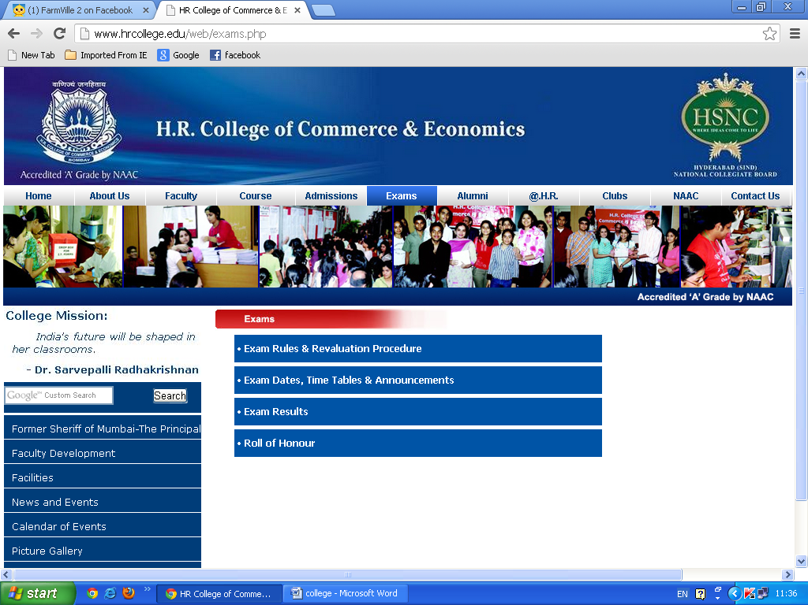

|  |  |  |  |  |  |  |  |  |  |  |  |  |  |  |  |  |  |  |  |  |  |  |  |  |  |  |  |  |  |  |  |  |  |  |  |  |  |  |
| --- | --- | --- | --- | --- | --- | --- | --- | --- | --- | --- | --- | --- | --- | --- | --- | --- | --- | --- | --- | --- | --- | --- | --- | --- | --- | --- | --- | --- | --- | --- | --- | --- | --- | --- | --- | --- | --- | --- |
| http://www.hrcollege.edu/web/images/trans.gif **I. FIRST AND SECOND TERM EXAMINATIONS: As prescribed by the Mumbai University**  There shall be two examinations for F.Y. & S.Y.B.Com., one at the end of each term and they shall be called First Term Examination and Second Term Examination respectively. Both Term Examinations shall be of equal marks and of equal duration. The First Term Examination shall be based on the portion of the syllabus taught in First Term and the Second Term Examination shall be based on the portion of the syllabus taught in Second Term as prescribed and approved by the concerned bodies of the University of Mumbai.   **II. SCHEME FOR PAPERS**  First Term Examination Max. Marks: 50 Duration: 2 Hrs Second Term Examination Max. Marks: 50 Duration: 2 Hrs N.B.: In the subjects where Tutorials are prescribed, marks secured in each paper shall be appropriately converted into theory component (i.e. marks out of 40 or 45 as applicable).   **III. ADDITIONAL EXAMINATION**  A – Eligibility to appear at the additional examination  A student who does not appear in some or all the papers, either at the First Term Examination or at the Second Term Examination on medical grounds or for representing the college or University in sports, cultural activities, NCC, NSS is eligible to appear for additional examination. A student who does not appear at both term examination shall not be eligible to appear for additional examination.  B – Nature of the additional examination  The additional examination shall be of two hours duration and of 50 marks per subject. The student shall appear for the paper/ subject of term examination which he/she has missed.   **IV. STANDARD OF PASSING**  The passing in the subject shall be based on the aggregate of marks of the First and Second Term Examinations taken together or marks of First term Examination and the additional examination taken together or marks of Second term examination and the additional examination taken together. Candidate should score minimum of 35% marks in aggregate in each paper, to pass the examination. The appearance at both the term Examinations, Tutorial Evaluation and the Practical Examination shall be compulsory.   **V. GRACING**  The gracing shall be carried out as per the existing Ordinances of the University.   **VI. VERIFICATION OF MARKS**  There shall be no revaluation of answer-books at F.Y. and S.Y. B.Com examinations conducted by the college. However, the facility of verification of marks shall be available. Students must submit their application for verification alongwith photo copy of marksheet and necessary fees as prescribed within the stipulates time. The verification shall be done by the examination committee.   **VII. ANNUAL EXAMINATION**  A- Eligibility to appear at the annual examination  A student who has failed or is allowed to keep terms for higher class is eligible to appear at the annual examination.  B- Nature of Annual Examination  The Annual Examination shall be of three hours duration and of 100 marks per subject, where there are no practicals and of two hours duration and of 60 marks per papers subject where there are practicals. The paper shall be drawn over the entire syllabus and will be divided into two sections viz. Section I based on portion of Syllabus to be taught in First term and Section II based on portion of syllabus taught in Second Term. There shall be two annual examinations in an academic year, one before the end of First Term and other before the end of Second Term.   **VIII. PROCEDURE FOR INVESTIGATION IN CASE OF MALPRACTICES**  1. The candidate may be served a show cause notice and made aware of the charges/allegations reported against him to prepare his/her defence at the time of his/her appearance before the Unfair Means Inquiry Committee and informing him/her thereby, of the proposed action to be taken in his/ her case with a request to reply to the show cause notice as to why the action proposed under it should not be taken against him/her.  2. The reply received by the Committee from the candidate when he/she appears before it, will be considered by the Committee and the final recommendation in the matter be made.  3. The punishment finally awarded can be equal to or less than what is mentioned in the show cause notice, but not more than what is mentioned therein.  4. The College Unfair Means Inquiry Committee is a recommendatory body. The Principal has to exercise his/her power U/S 87 of the Mumbai University Act, 1974 and issue final order.The Broad Categories of Unfair means Resorted to by Students at the University /College/Institution Examinations and the Quantum of Punishment for each category thereof.   |  |  | | --- | --- | | **Sr. Nature of malpractice** | **Quantum of Punishment** | | 1. Possession of copying material | Annulment of the performance of the student at the University/College/Institution examination in full. * (Note : This quantum of punishment shall apply also to the to the following categories of malpractices at Sr. No. (2) to Sr. No. (12) in addition to the punishment prescribed threat. | | 2. Actual copying from the copying material | Exculsion of the students from University or College or Institution examination for one additional examination. | | 3. Possession of another student’s answer-book | Exculsion of the student from University or College or Institution examination for one additional examination. (Both the Students) | | 4. Possession of another student’s answer-book+ actual evidence of copying therefrom. | Exculsion of the student from University or College or Institution examination for two additional examinations. (Both the Students) | | 5. Mutual / Mass Copying | Exculsion of the student from University or College or Institution examination for two additional examinations. | | 6. I) Smuggling-out or smuggling-in of answerbook as copying material. | Exculsion of the student from University or College or Institution examination for two additional examinations. | | II) Smuggling-in of written answerbook based on the question paper set at the examinations. | Exculsion of the student from University or College or Institution examination for three additional examinations. | | III) Smuggling-in of written answerbook and forging signature of the Jr. Supervisor thereon. | Exculsion of the student from University or College or Institution examination for four additional examinations. | | 7. Attempt to forge the signature of the Jr. Supervisor on the answerbook or Supplement | Exculsion of the student from University or College or Institution examination for four additional examinations. | | 8. Interfering with or counterfeiting of University/College / Institution seal, or answerbooks or office stationery used in the examinations. | Exculsion of the student from University or College or Institution examination for four additional examinations. | | 9. Answerbook, main or supplement written outside the examination hall or any other insertation in the answerbook. | Exculsion of the student from University or College or Institution examination for four additional examinations. | | 10. Insertion of currency notes to bribe or attempting to bribe any of the person/s connected with the conduct of examinations. | Exculsion of the student from University or College or Institution examination for four additional examinations. (Note : This money shall be credited to the Vice-Chancellor’s Fund) | | 11. Using obscene language/ violence threat at the examination centre by a student at the University / College / Institution examination to Jr./Sr. Supervisors / Chief Conductor or Examiners | Exculsion of the student from University or College or Institution examination for four additional examinations. | | 12. a. impersonation at the the University / College / Institution examination | Exculsion of the student from University or College or Institution examination for five additional examinations. (both the students if impersonator is University or College or Institute student) | | b. impersonation by a University / College / Institute Student at S.S.C. H.S.C. / any other examinations. | Exculsion of the student from University or College or Institution examination for five additional examinations. | | 13. Revealing identity in any form in the answer written or in any other part of the answerbook by the student at the University or College or Institution examination. | Annulment of the performance of the student at the University/College/Institution examination in full | | 14. Found having written on palms or on the body or on the clothes while in examination. | Annulment of the performance of the student at the University/College/Institution examination in full. | | 15. All other malpractices not covered in the aforesaid categories. | Annulment of the performance of the student at the University/College/Institution examination in full and severe punishment depending upon the gravity of the offence. |   16. If on previous occasion a disciplinary action was taken against a student for malpractice used at examination and he/she is caught again for malpractice used at the examinations, in this event he/she shall be dealt with severely. Enhanced punishment can be imposed on such students . This enhanced punishment may extend to double the punishment provided for the offence, when committed at the second or subsequent examination.  17. Practical / Dissertation/Project Report Examination Student involved in malpractices at the Practical / Dissertation/Project Report Examinations shall be dealth with as per the punishment provided for the theory examination.  18. The Competent Authority, in addition to the above mentioned punishments may impose a fine on the student declared guilty.  * (Note : The Term “Annulment of Performance in full” includes performance of the student at the theory as well as Annual Practical examination, but does not include performance at term work, project work with its term work, oral or practical and dissertation examinations unless malpractice used thereat. |

Alumni

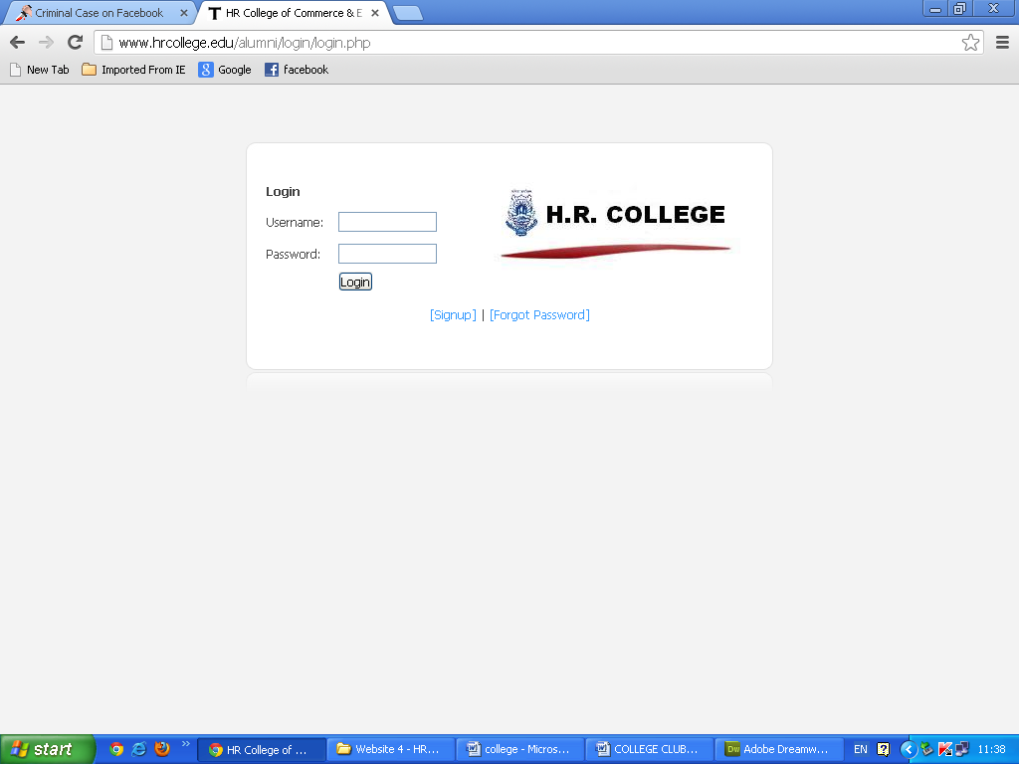

Gallery

|  |  |  |  |  |  |  |  |  |  |  |  |  |  |  |  |  |  |  |  |  |  |  |  |  |  |  |  |  |  |  |  |  |  |  |  |  |  |  |  |  |  |  |  |  |  |  |  |  |  |  |  |  |  |  |  |  |  |  |  |  |  |  |  |  |  |  |  |  |  |  |  |  |  |  |  |  |  |  |  |  |  |  |  |  |  |  |  |  |  |
| --- | --- | --- | --- | --- | --- | --- | --- | --- | --- | --- | --- | --- | --- | --- | --- | --- | --- | --- | --- | --- | --- | --- | --- | --- | --- | --- | --- | --- | --- | --- | --- | --- | --- | --- | --- | --- | --- | --- | --- | --- | --- | --- | --- | --- | --- | --- | --- | --- | --- | --- | --- | --- | --- | --- | --- | --- | --- | --- | --- | --- | --- | --- | --- | --- | --- | --- | --- | --- | --- | --- | --- | --- | --- | --- | --- | --- | --- | --- | --- | --- | --- | --- | --- | --- | --- | --- | --- | --- | --- |
| |  |  |  |  | | --- | --- | --- | --- | | **HR PULSE** | | |  | |  |  |  |  |  | | http://www.hrcollege.edu/web/images/trans.gif | http://www.hrcollege.edu/web/images/gallery/0361.JPG | http://www.hrcollege.edu/web/images/trans.gif | http://www.hrcollege.edu/web/images/gallery/0461.JPG | http://www.hrcollege.edu/web/images/trans.gif | |  |  |  |  |  | |  | http://www.hrcollege.edu/web/images/gallery/DSC_00691.JPG |  | http://www.hrcollege.edu/web/images/gallery/DSC_00711.JPG |  | |  |  |  |  |  | |  | http://www.hrcollege.edu/web/images/gallery/DSC_01251.JPG |  | http://www.hrcollege.edu/web/images/gallery/DSC_01351.JPG |  | |  |  |  |  |  | |  | http://www.hrcollege.edu/web/images/gallery/038.JPG |  | http://www.hrcollege.edu/web/images/gallery/039.JPG |  | |  |  |  |  |  | |  | http://www.hrcollege.edu/web/images/gallery/DSC_0076.JPG |  | http://www.hrcollege.edu/web/images/gallery/DSC_0120.JPG |  | |  |  |  |  |  | |  | http://www.hrcollege.edu/web/images/gallery/DSC_0184.JPG |  | http://www.hrcollege.edu/web/images/gallery/DSC_0252.JPG |  | |  |  |  |  |  | |  | http://www.hrcollege.edu/web/images/gallery/DSC_0118.JPG |  | http://www.hrcollege.edu/web/images/gallery/DSC_0127.JPG |  | |  |  |  |  |  | |  | http://www.hrcollege.edu/web/images/gallery/DSC_0208.JPG |  |  |  | |  |  |  |  |  | |